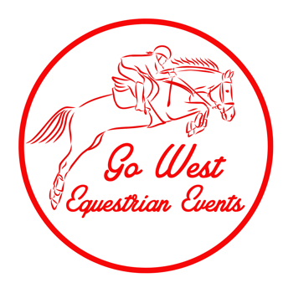

Hire Terms & Conditions

1. The Hirer must contact Go West Equestrian Events (Go West) to inform them of their intentions to hire prior to submitting the Showjump trailer (‘trailer’) and Bockmann Horse Float (‘float’) **HIRE FORM**, so dates can be checked for availability.
2. If the trailer or float (as nominated by the Hirer on the **HIRE FORM)** is available as advised by Go West, the **HIRE FORM** must be completed and returned to the email address ([hello@gowestequestrianevents.com](mailto:hello@gowestequestrianevents.com)). The Hirer will be sent an invoice, with confirmation of payment (receipt of transfer of monies) of the required fee to confirm the booking. This must be done at least **3 weeks prior** to the date required.
3. Delivery and collection of the trailer can be arranged if advanced notice is provided, and this included, where possible delivery to WPNEC and Elcho Park.
4. Upon collection of the trailer, Go West shall ensure that all the equipment (including poles, wings, cups and planks) is accounted for. Should the trailer not be in the condition and presentation it left the Go West, the Hirer is to pay a repacking fee $200.
5. For the duration of the hire period, the Hirer assumes responsibility for the trailer (including all the equipment contained on the trailer) from collection at the Go West shed until it is returned to the Go West shed (or mutually agreed location). Should the trailer be damaged during the hire period the Hirer will be responsible for the **total cost of repair**.
6. For the duration of the hire period, the Hirer assumes responsibility for the float from collection at the Go West shed until it is returned to the Go West shed (or mutually agreed location). Should the float be damaged during the hire period the Hirer will be responsible for the **total cost of repair**.
7. The Hirer is responsible for the cost of damaged or lost equipment (including poles, wings, cups and planks) for the duration of the hire. The Hirer agrees to pay for the following breakages;  
   – $50 per pole  
   – $100 per plank  
   – $40 per breakaway cup  
   – $20 per standard cup  
   – Wings and gates shall be repaired or replaced at a fair market price.
8. The Hirer indemnifies Go West against all losses, damages, claims, liabilities, expenses, payments or outgoings arising from the Hirers transportation and subsequent use of the trailer and float, and all equipment contained on the trailer for the duration of the hire period. This includes, but is not limited to claims for loss, compensation or damages due to personal injury or property damages; and all other legal actions and proceedings, costs, charges, outgoings, expenses and other payments.